**Route App**



**Supervisor**

Ma’am Alina Munir

**Submitted by**

Muhammad Salman  
{2021_SE_04}

Noman Ahmad  
{2021_SE_11}

Farjad Waseem  
{2021_SE_34}

**Department of Computer Science,**

University of Engineering and Technology, Lahore, New-Campus.

TABLE OF CONTENT

Description: 3

Scope: 3

Vision Statement: 3

Work Break-down Structure: 4

Timeline / Gantt Chart: 5

# Description:

Our team will be developing a bus tracking system that allows students, teachers, and staff to view live bus locations, routes, pickup points, and estimated time of arrival. The system will feature an admin dashboard for managing bus and driver information, routes, and pickup points, and sending custom notifications to all users. The system will use driver’s mobile phone as a GPS tracking system for the bus and include user-friendly interfaces for mobile platforms. Our goal is to create a secure, reliable, and user-friendly system that enhances the overall transportation experience.

# Scope:

The scope of route app involves the development of a software platform that enables the management for all bus routes. The system should be designed to facilitate the students and staff to view the stops and tracks of all the routes, their live location and also any alternative route their route is missed. The system should allow the driver to start and stop the route tracking. The system should also allow the admin to send to add or remove new route or stops in the route, add or block any user, driver and to assign a route to the driver.

# Vision Statement:

For students, staff members, and transport officers, who want to check and track their bus route via mobile app. KSK Routes is a bus route tracking app that will provide the facility to students and staff members to track their specific buses and the current location of the bus. Unlike Google Maps, the focus is to provide students and staff members an interactive UI and push notifications in case their route bus has started. Our product will lessen the transport office’s burden of managing everyday student-driver issues and provide students or staff members with effective ways to reach university in case their route is missed.

# Work Break-down Structure:

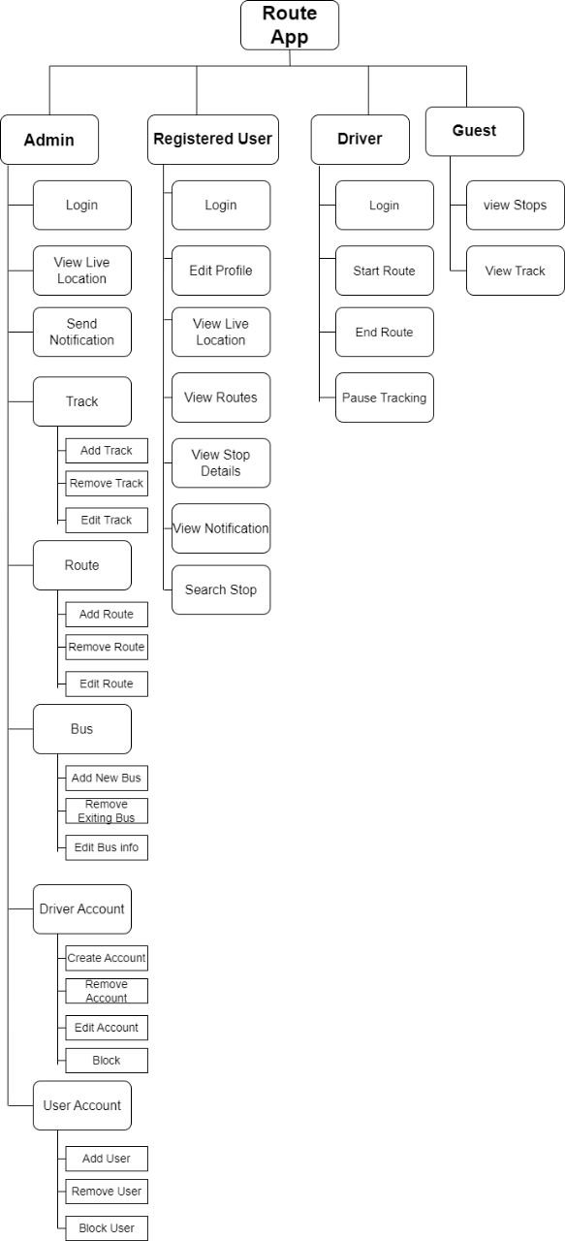

# Timeline / Gantt Chart:

|  |  |  |  |  |
| --- | --- | --- | --- | --- |
| Steps | First Week | Second Week | Third Week | Fourth Week |
| Scope,Vision of the project |  |  |  |  |
| Requirement of the Project |  |  |  |  |
| Story Boards of the Project |  |  |  |  |
| Use Cases |  |  |  |  |
| UML Diagrams of the project |  |  |  |  |
| Test Cases |  |  |  |  |
| Building of the prototype |  |  |  |  |